Register as a contributor to the case
Anti-dumping measures applicable to imports of certain pre- and post-stressing wires and wire strands of non-alloy steel (PSC wires and strands) originating in the People’s Republic of China
Case TD0003: PSC wire and strands exported from the People’s Republic of China

Period of Investigation: | 01 January 2019 – 31 December 2019
Injury Period: | 01 January 2016 – 31 December 2019
Deadline for response: | 14 August 2020
Case Team Contact: | TD0003@traderemedies.gov.uk
Completed on behalf of: | UK Steel (part of Make UK, the Manufacturers’ Organisation – legally registered as EEF Limited)

This form should be returned to TRID using the Trade Remedies Service (www.trade-remedies.service.gov.uk).

Table of Contents

Section A – Your organisation’s interest in the case 3
Section B – Additional information 4
Section C – Certification 5

Section A – Your organisation’s interest in the case

To register your organisation’s interest in this case, please complete the text boxes below. You should use this form if you are not a producer, importer or exporter of the goods subject to review or like goods. For a definition of goods subject to review/like goods, please refer to the Notice of Initiation.

Please describe the role of your organisation with regards to the goods subject to review or the like goods:
UK Steel is the trade association for the United Kingdom’s steel industry – representing all of the country’s steel producers and the vast majority of its downstream processers.
In this capacity it represents the interests of the UK producer of the product in question, pre-stressed wires and strands, as well as upstream producers of the primary raw material for this product – namely wire rod.

Please describe your interest in this case:
UK Steel represents the interests of the UK’s steel producing companies, including those of the product forming the subject of this transition review: PSC Wires and Strands

UK Steel welcomes the opening of this transition review. It is critical that the transitioned anti-dumping measures on PSC Wires and Strands from the People’s Republic of China be maintained at their current levels.

Section B – Additional information

Use the box at the end of this section to provide any other relevant information which you think would be useful to help our investigation.

This may include:

- other parties you believe should receive a questionnaire;

- any initial views you have about the possible existence of a particular market situation in the domestic market of the exporting country or territory such as:
  - situations/distortions in the domestic market of the exporting country where prices are artificially low;
  - significant barter trade;
  - prices reflect non-commercial factors; or
  - any other reason
which means it is not appropriate to use the comparable price to determine the normal value of the goods subject to review;

- the scope of the investigation; or

- anything else you consider relevant.
Please see UK Steel’s separate, attached submission.

Section C – Certification

The undersigned certifies that the information supplied herein is correct and complete to the best of his/her knowledge and belief.
The undersigned certifies that he/she has the authority to supply the information contained herein on behalf of his/her organisation.

Signature (including e-signature):
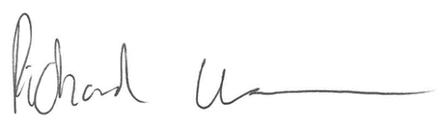
Name: Richard Warren

Position at company: Head of Policy and External Affairs

Date: 14.08.2020

