SECTION B: Next steps and declaration

Next steps

Once you have completed all parts of the questionnaire, the declaration below should be signed.

Please upload this questionnaire to both cases (TD004 and TS005) through the Trade Remedies Service (www.trade-remedies.service.gov.uk) by 8th November 2020.

A confidential and non-confidential version of the questionnaire must be submitted. You can find guidance on how to complete confidential and non-confidential versions at www.gov.uk/government/publications/the-uk-trade-remedies-investigations-process/an-introduction-to-our-investigations-process#handling-confidential-information.

Declaration

By signing this declaration, you agree that all information supplied in this questionnaire is complete and correct to the best of your knowledge and belief and that you understand that the information you submit may be subject to verification by TRID.

Company name: Diamond Green Diesel LLC
Company registration number (if applicable): FEIN: 80-0492539

20 November 2020 |  | 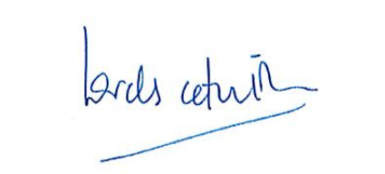
Date |  | Signature of authorised official
[CONFIDENTIAL : personal identifying information], Partner, Hogan Lovells
Name and title of authorised official

