Transition Review Dumping Questionnaire for (Interested Parties/Contributors)

Case TD0026: Hot Rolled Flat and Coil Products exported from the Russian Federation, Ukraine, the Federative Republic of Brazil and the Islamic Republic of Iran

Period of Investigation (POI): | 1 April 2021 – 31 March 2022
Injury period: | 1 April 2018 – 31 March 2022
Deadline for response: | 5 September 2022
Contact details: | TD0026@traderemedies.gov.uk
Completed on behalf of: | Government of Brazil

When you have completed this form, indicate the confidentiality status of this document by placing an X in the relevant box below:

☐ Confidential
X Non-confidential – will be made publicly available

Please note that you will have to provide a Confidential and a Non-Confidential version of both the questionnaire and annex, as well as any additional documents you append. All documents should be uploaded to the Trade Remedies Service (www.trade-remedies.service.gov.uk) by 5 September 2022.

Table of Contents

Introduction 3
About us, this case and this questionnaire 3
Instructions on completing this questionnaire 4
The scope of this review 6
Goods subject to review 6
SECTION A: About the case 7
A1 General information 7
A2 Information about this review 8
SECTION B: Dumping 9
B1 Dumping 9

Introduction

About us, this case and this questionnaire

The Trade Remedies Authority (TRA) investigates whether trade remedies are needed to prevent injury to UK industry.

The TRA will carry out a transition review of each trade remedy measure active under the EU system that the UK has decided to maintain after EU exit. This transition review will consider whether dumped imports of Hot Rolled Flat and Coil products from the Russian Federation, Ukraine, the Federative Republic of Brazil and/or the Islamic Republic of Iran are likely to continue or recur if the measure was removed and whether injury would be likely to continue or recur to the UK industry if this measure was removed.

Why should I take part?

We are asking contributors and interested parties to complete this questionnaire to inform our review of whether the current anti-dumping measure should be maintained, varied or revoked.

Please refer to our online guidance to understand more about how we carry out transition reviews into EU measures and the differences between interested parties and contributors.

How do I respond?

Detailed guidance on how to complete the questionnaire is provided in the instructions section below.

Please provide all the information requested by 5 September 2022. We may send a notice asking for clarification or supplementary information where necessary. Make sure you provide the sources for any information or data you don’t own and clearly state any restrictions on sharing it.

Where can I find more information?

Our trade remedies guidance provides more information about our investigations and processes we follow.

If you have any specific questions relating to the case, now or while you’re completing the questionnaire, please contact the Case Team at TD0026@traderemedies.gov.uk
For general information about trade remedies processes, please see our online guidance.

You can also find out more about the regulatory basis of our investigations. The TRA investigates cases under the provisions of Trade Remedies (Dumping and Subsidisation) (EU Exit) Regulations 2019 as Amended by the Trade Remedies (Amendment) (EU Exit) Regulations 2019 and under the Taxation (Cross-border Trade) Act 2018.

Instructions on completing this questionnaire

Preparing your response

This section sets out guidance on how to complete this questionnaire

If you think you won’t be able to complete the questionnaire within the required time, please contact the Case Team ahead of the deadline using the contact details on the cover of this questionnaire. You should outline the length of extension you need and the reasons why. We will notify you of our decision.

If we can accommodate an extension, we will publish a note on our public file to record both the request and the extension granted.

Preparing confidential and non-confidential copies

You will need to submit one confidential version and one non-confidential version of your questionnaire by the due date. We will publish the non-confidential version on the public file. Please ensure that each page of information you provide is clearly marked either “Confidential” or “Non-Confidential” in the header.

Please see our guidance on how to submit information for further details on what can be considered confidential and how to prepare a non-confidential version of this questionnaire.

In preparing your response, please note the following:
- It is your responsibility to ensure that the non-confidential version does not contain any confidential information.
- Remember to include a statement explaining why information obtained in your response should be treated as confidential (e.g., the data is commercially sensitive).
- Provide the source for all information or data you don’t own and clearly state any restrictions on sharing it.
- If you do not provide a non-confidential summary (or a statement of reasons why you cannot provide this) each time you provide confidential information, the TRA may disregard the information you give us.

All information provided to the TRA in confidence will be treated accordingly and only used for this investigation (except in limited circumstance as permitted by regulation 46 of the Trade Remedies (Dumping and Subsidisation) (EU Exit) Regulations 2019) and will be stored in protected systems. The non-confidential version of your submission will be placed on the public file, which is available on www.trade-remedies.service.gov.uk/public/cases.

How to complete this questionnaire

All statements should be substantiated with relevant data, information and the sources of these. Please attach supporting documents in appendices to supplement your responses. To help us verify your information, please retain all your supporting documents, including any calculations made when developing your responses.

Please also note the following points:
- Do not leave any questions blank. If the question is not relevant to your organisation, please explain why. If the answer to a question is “zero”, “no” or “none”, please write this.
- If there is insufficient space in any part of the questionnaire to provide the details requested, or we ask for copies of additional information, please submit this information as appendices. Please ensure that any attachments are given a corresponding appendix reference in the title of the document and that these are referenced in the boxes provided.
- Any documents not in English should be accompanied by an English translation.
- Please provide all dates in the format DD/MM/YYYY (e.g. 23/05/2019).
- Identify all units of measurement and currencies used in tables, calculations and lists.
- For all numerical figures, where appropriate please express every third number with a comma (e.g. ‘1,300’ for one-thousand three hundred, ‘1,300,000’ for one million and three-hundred thousand).
- Please refer to the case number, TD0026, in any correspondence with the TRA.

What happens next

Once you have completed your questionnaire responses, you must upload confidential and non-confidential versions along with any additional documents you’re providing through our Trade Remedies Service. Following this:
- you will receive an email confirming the documents have been uploaded successfully;
- the Case Team will contact you if further information is required; and
- the non-confidential responses will be placed on the public file.

For further information please refer to our guidance on how we carry out transition reviews into EU measures

The scope of this review

Goods subject to review

This review covers certain hot-rolled flat products of iron, non-alloy or other alloy steel exported from the Russian Federation, Ukraine, the Federative Republic of Brazil and the Islamic Republic of Iran, described as:

Certain flat-rolled products of iron, non-alloy steel or other alloy steel, whether or not in coils (including ‘cut-to-length’ and ‘narrow strip’ products), not further worked than hot-rolled, not clad, plated or coated.
The following product types are excluded: Products of stainless steel and grain-oriented silicon electrical steel; products of tool steel and high-speed steel; products, not in coils, without patterns in relief, of a thickness exceeding 10mm and of a width of 600mm or more; products, not in coils, without patterns in relief, of a thickness of 4.75mm or more but not exceeding 10mm and of a width of 2.05m or more.

These products are currently classifiable within the following CN code(s):

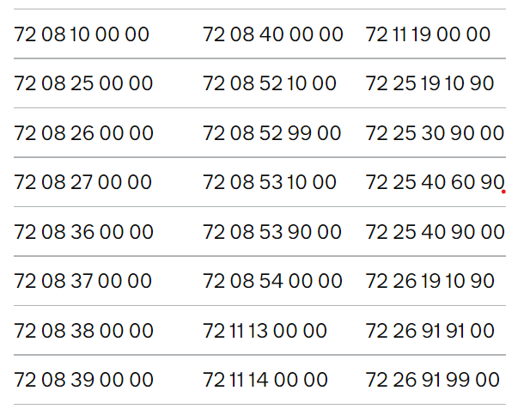

The commodity code 72 26 19 10 90 was replaced by commodity codes 72 26 19 10 91 and 72 26 19 10 95 on 9 July 2021.

These codes are only given for information.

In this questionnaire, these goods will be referred to as ‘the goods subject to review’. Any reference to ‘goods subject to review’ in this questionnaire refers to the goods description above, regardless of the commodity code under which they are exported.

SECTION A: About the case

A1 General information

- Please complete the table below. Make sure the point of contact you name has the authority to provide this information.

Name (point of contact):
Address:
Telephone No:
Email:
Website:

If you are representing a company, please also fill in the information below:

Company registration number:
Place of registration:
Legal name of organisation:
Legal structure (e.g. limited company, sole trader, partnership etc):
Position in the organisation:
Year of establishment:
Other operating names:

- Please explain your interest in this review.

As a country that exports to the United Kingdom the goods subject to review, Brazil is interested in participating in the process, contributing to it with comments, and having access to relevant documentation circulated.

Additionally, Brazil has been actively contributing to international efforts to promote the sustainability of the steel industry around the world. In 2022, Brazil is serving as one of the co-chairs of the Global Forum on Steel Excess Capacity (GFSEC), a multilateral platform to discuss and find collective solutions to the challenge of excess capacity and promote market conditions in the steel sector.
Appendix reference:

A2 Information about this review

Please give any information you feel is relevant to the case. This transition review will consider whether the current anti-dumping measure is necessary or sufficient to offset the effect of dumping and whether there would be injury to the UK industry if the measure was removed.

- Please provide any information about the goods subject to review that you consider relevant.

Regarding this question, the Government of Brazil has no information to present at the moment.
Appendix reference:

- Do you think there would be injury to the UK industry if the existing anti-dumping measure for the goods subject to review no longer applied? Provide any information supporting your conclusions including what the cause of this injury would be. You can refer to our guidance on how we assess injury for a definition of injury.

The Government of Brazil (GBR) is of the view that the revocation of the AD measure on the hot-rolled flat products of iron, non-alloy or other alloy steel (HRS) imports from Brazil will not lead to the continuation or recurrence of material injury to the UK domestic industry.

Subject imports from Brazil maintained a very small presence in the UK market during the POI (See Appendix I). The Brazilian industry is not export oriented and its relatively low exports (11,4% of all HRS produced in 2021) are mostly (64,3% of exports) directed to markets that provide tariff preferences for Brazilian steel industry, such as Latin America (See Appendix II).

The share of HRS exports in total sales is decreasing for the past years whereas HRS domestic consumption expands (See Appendix III). The Brazilian HRS industry focus on servicing its domestic market and this trend will continue in the reasonably foreseeable future.

Furthermore, as Brazil has been stating to the OECD and the G20, there are no planned production capacity expansions in Brazil for HRS, which indicates there will not be a surge in exports from Brazil if the measure is revoked considering its limited capacity.
Appendix reference:

Appendix I – Brazilian Share of Exports in UK Imports - ONS.xlsx

Appendix II - 2022 IABR Annual Report - Exports by Country of Destination 2021.pdf

Appendix III - 2022 IABR Annual Report - Brazilian Exports and Domestic Consumption.pdf

- Please provide any information about the possible economic effects on the UK if the existing anti-dumping measure on the goods subject to review were no longer applied.

The UK investigating authority should find that imports from Brazil would likely have no discernible adverse impact on the domestic industry if the measure were revoked. The current volumes of exports of HRS from Brazil to the United Kingdom are low.

The insignificant volume of imports from Brazil is unlikely to have a significant effect on the UK domestic industry’s prices and to lead to a significant impact on the domestic industry. Brazilian exporters have also informed the GBR that the demand of HRS in the Brazilian domestic market is increasingly high. In fact, the demand for steel in the Brazilian market is increasing, which indicate less room for exports. HRS is used in key downstream industries such as agricultural machinery, construction, oil & gas, automotive, which are also experiencing growth (See Appendices IV, V, VI and VII).

The TRA should also be mindful of the current volumes of Brazilian exports when determining whether to cumulate imports from Brazil with imports from the other investigated countries or not, in the injury analysis, especially in light of the recent events involving Russia and Ukraine and its volume of imports into the UK.

Finally, when assessing the eventual continuation of any alleged injury, the TRA should distinguish the injury caused, in 2020 and 2021, by the covid-19 pandemic as well as by the Russia-Ukraine conflict from that supposedly caused by the subject imports.
Appendix reference:

Appendix IV - Brazil's GDP tops expectations – Reuters.pdf

Appendix V - Brazil Tractors Market Report 2022-2028 Business Wire.pdf

Appendix VI - Construction activity in Brazil - Design Build Network.pdf

Appendix VII - Global investment in oil and gas grows in 2022 and Brazil stands out – Enauta.pdf

- If you have any other information which may help us with this review, please provide it below.

In Brazil, steel demand rose sharply by 23.4% to 26.7 mmt in 2021, according to the local steelmakers’ association Brazil Steel Institute (Instituto Aço Brazil - IABr).

Brazilian domestic demand shall continue to play a more significant role to Brazilian producers since several economy recovery restrictions have started to decrease, social transfers from new government programs have increased purchasing power and higher inflation is being checked by accelerated pace of monetary policy by Brazil’s Central Bank and a deflation scenario from July 2022 onwards on the wake of continuous cuts on fuels prices, normalization of electricity prices after increases due to rainfall reduction in 2021.

It is also worth highlighting that steel demand in Central and South America was expected to grow by 23.2% in 2021, the highest growth rate across regions. In November 2021, Alacero, the Latin American Steel Association, estimated that steel consumption in Latin America increased by 19% in 2021 and reached the highest level since 2014 due to a strong post COVID-19 economic recovery in the Latin America region.

SECTION B: Dumping

B1 Dumping

- Do you have any information about the normal value of the goods subject to review in the Russian Federation, Ukraine, the Federative Republic of Brazil and/or the Islamic Republic of Iran? Please substantiate with evidence where possible.

Regarding this question, the Government of Brazil has no information to present at the moment.

Appendix reference:

- Do you have any information about the export price of the goods subject to review from the Russian Federation, Ukraine, the Federative Republic of Brazil and/or the Islamic Republic of Iran? Please substantiate with evidence where possible.

Regarding this question, the Government of Brazil has no information to present at the moment.
Appendix reference:

F2 Likelihood of dumping

- Do you have any information about the capacity and capacity utilisation among exporters of the goods subject to review during the POI? Please provide estimates and substantiate with evidence where possible.

Brazil Steel Institute’s 2022 Annual Report presents data on capacity and capacity utilization of the steel industry as a whole.

Since there is no foreseen relevant investment to increase the production capacity, Brazil’s production is limited and tends to be focused on domestic and regional markets, as previously explained.

 | 2018 | 2019 | 2020 | 2021 | 2018-2021
Installed Capacity  (10^3 t. crude steel/year) | 51.450 | 51.450 | 50.950 | 50.950
var (%) |  | 0,00% | -0,97% | 0,00% | -0,97%
Source: Aço Brazil/worldsteel/ALACERO/Min.da Economia-SECEX
(extracted from https://acoBrazil.org.br/site/wp-content/uploads/2022/07/AcoBrazil_Anuario_2022.pdf)

Also as per Brazil Steel Databook – 2022, Brazil’s capacity utilization rate is reaching, in 2021, values previously seen only between 2012 to 2014.
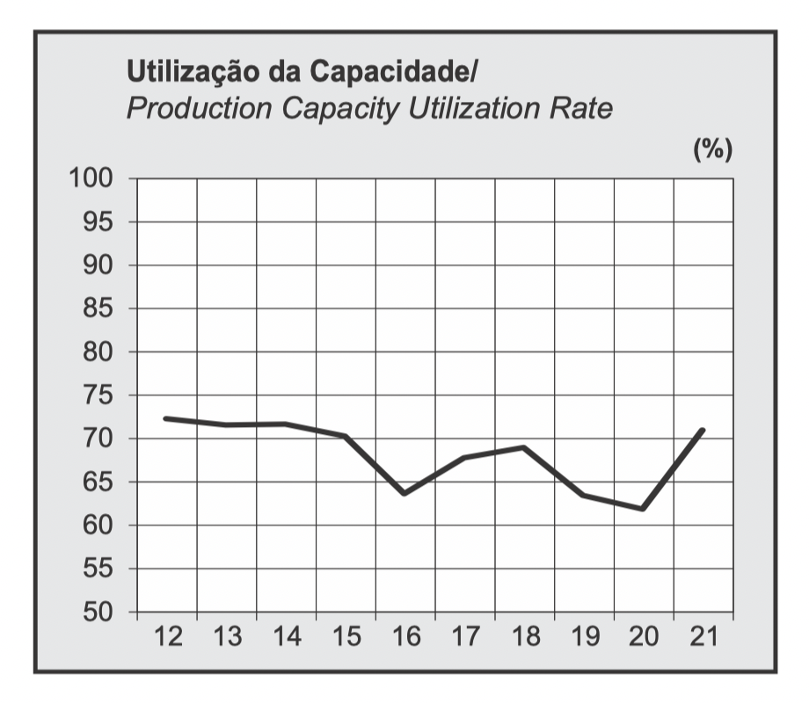

Source: https://acoBrazil.org.br/site/wp-content/uploads/2022/08/MBA_Edição_2022.pdf

Appendix reference:

- Please provide any additional information that might inform our assessment of whether imports of the goods concerned are likely to be dumped if the measure is removed.

Regarding this question, the Government of Brazil has no information to present at the moment.

Appendix reference:

