Data showing the volumes of production of hot-rolled steel (sheets and coils)
(2016-2021) (page 25)
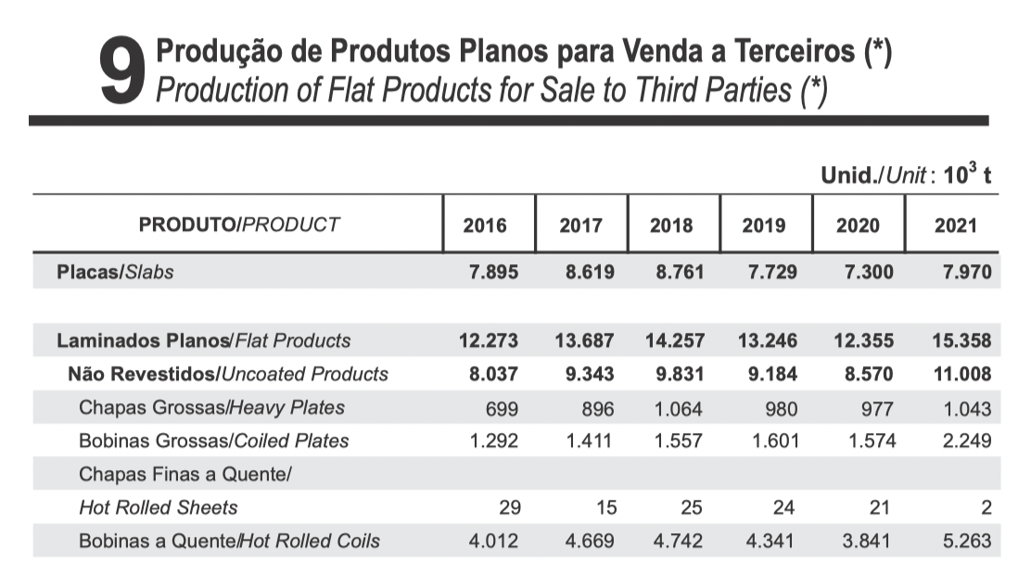

Data showing export volumes of hot-rolled steel (sheets and coils) – 2021 (page 39) (Approximately 11,4% of production volumes)
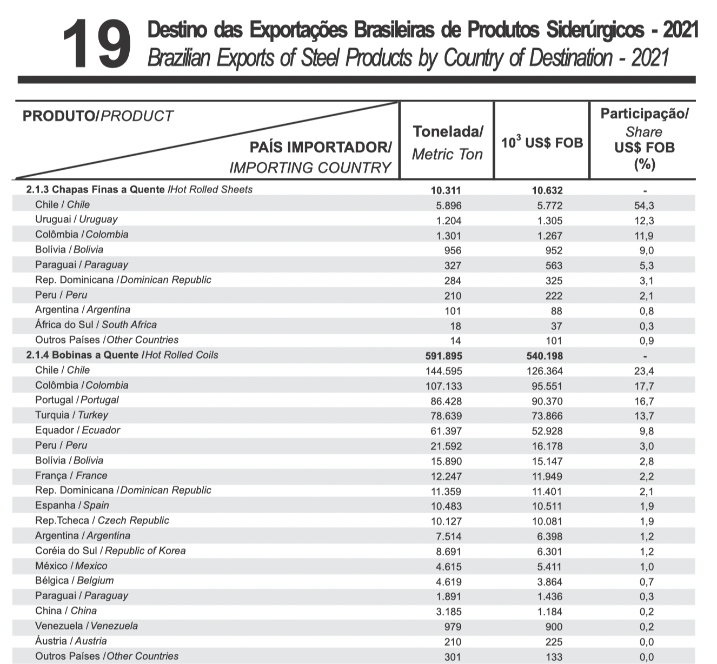

Source: https://acobrasil.org.br/site/wp-content/uploads/2022/08/MBA_Edição_2022.pdf

