Data showing decreasing share of exports in total sales 2018-2021 (page 12)
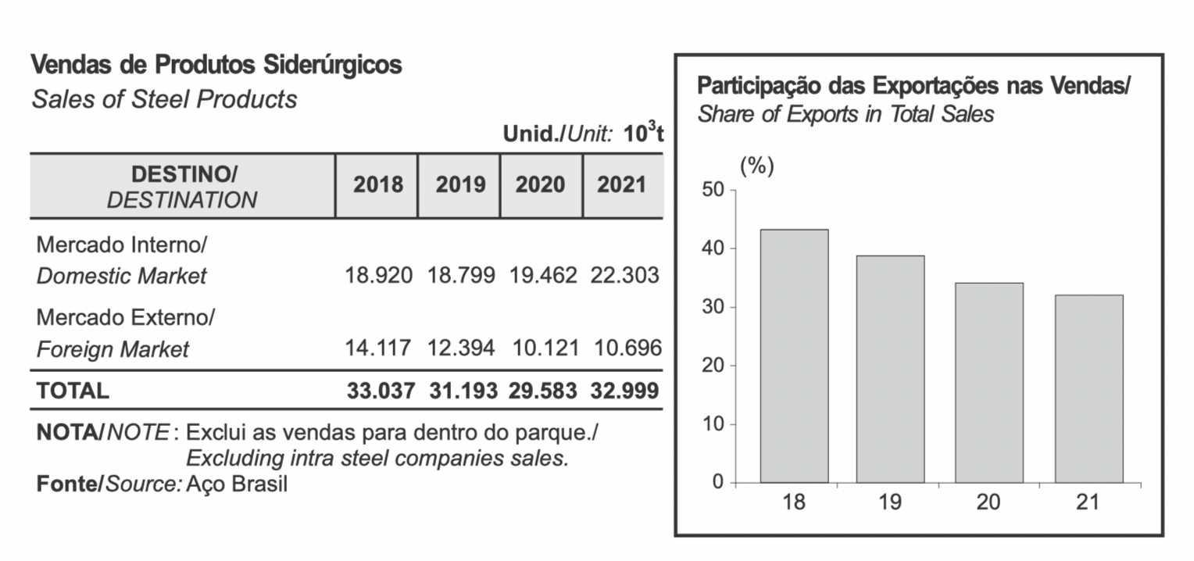
Source: https://acobrasil.org.br/site/wp-content/uploads/2022/08/MBA_Edição_2022.pdf

Data showing increasing volumes of hot-rolled steel domestic sales
(2016-2021) (page 30)

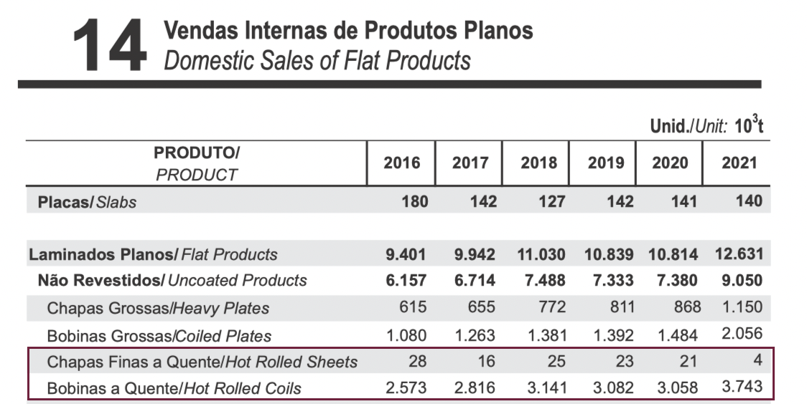

Source: https://acobrasil.org.br/site/wp-content/uploads/2022/08/MBA_Edição_2022.pdf

Data showing decreasing volumes of hot-rolled steel exports (2016-2021)
(pages 37 and 38)

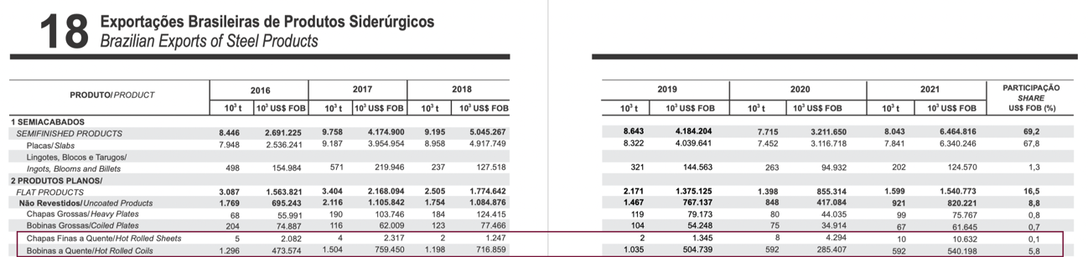

Source: https://acobrasil.org.br/site/wp-content/uploads/2022/08/MBA_Edição_2022.pdf

