Transition Review Dumping Questionnaire for (Interested Parties/Contributors)

Case TD0026: Hot Rolled Flat and Coil Products exported from the Russian Federation, Ukraine, the Federative Republic of Brazil and the Islamic Republic of Iran
Appendix. Novolipetsk Steel (NLMK Group)

Chart №1 The volume of supplies of HFRS from Russia

Source: Federal Customs Service of Russia database
URL: http://stat.customs.ru/analysis

Chart №2 The UK hot rolled steel production
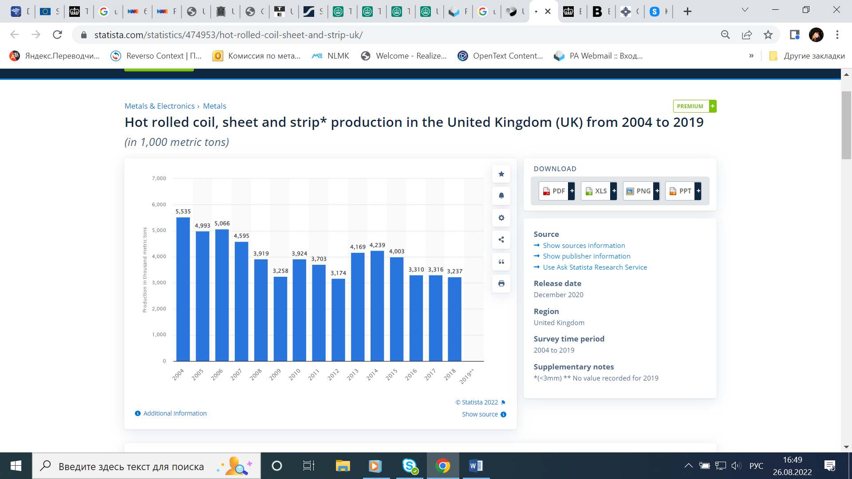
Source: Statista
URL: https://www.statista.com/statistics/474953/hot-rolled-coil-sheet-and-strip-uk/

Chart №3 The UK steel demand
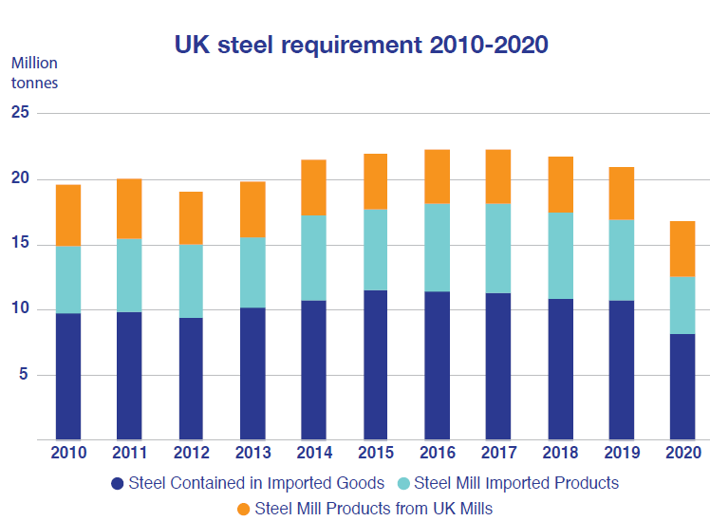

Source: Key Statistics Guide April 2021
URL: https://www.makeuk.org/uk-steel
Chart № 4 The UK steel demand
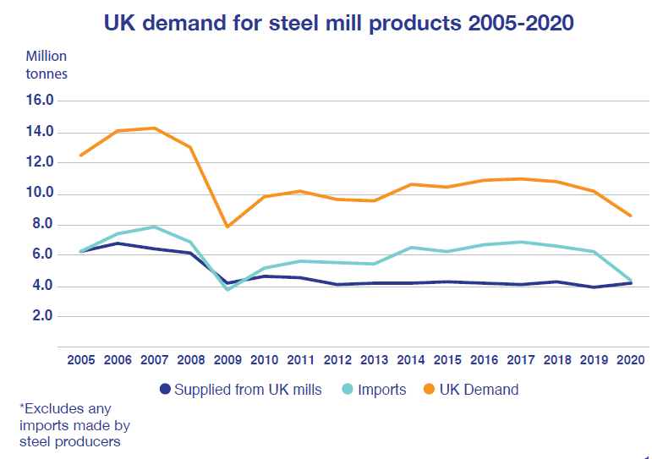
Source: Key Statistics Guide April 2021
URL: https://www.makeuk.org/uk-steel

Chart №5 Share of UK demand
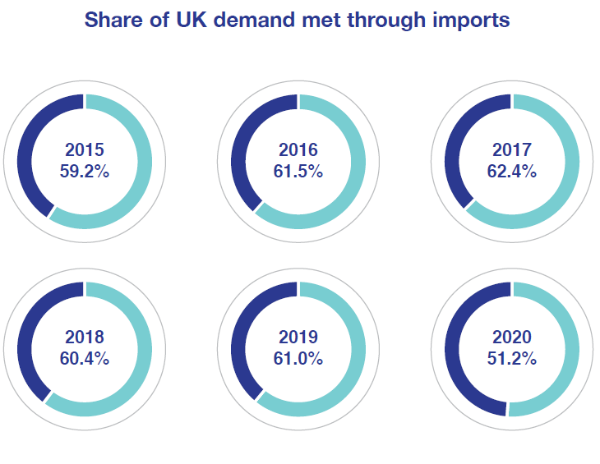
Source: Key Statistics Guide April 2021
URL: https://www.makeuk.org/uk-steel

Chart №6 UK HRC prices dynamics

Source: Novolipetsk Steel

Chart №7 Global HRC prices dynamics

Source: Kallanish Commodities
URL: https://www.kallanish.com/en/

