10/01/2022

Trade Remedies Authority

North Gate House

21-23 Valpy Street

Reading

RG1 1AF

**Response to Reconsideration Case (NON-CONFIDENTIAL)**

**TF0006: Safeguard measures on certain steel products**

**Black Country Local Enterprise Partnership (LEP)**

**Summary of Response**

To support an inclusive, green recovery that truly drives levelling-up, the **UK needs access to globally competitive steel sources and supply chains, currently restrained by quotas and tariffs caused by steel safeguarding measures.[1]** This is required until conditions allow for an efficient and sustainable British steel industry that can sustainably supply at the volume demanded.

To ensure the whole industry is as unburdened and competitive as possible, a re-balancing of the steel quotas system is required. **While elements of the Trade Remedies Authority’s (TRA) initial review of safeguards[2] took positive steps, further changes are required in addition to implementation by government.**

The Black Country, comprising the four local authority areas of Dudley, Sandwell, Walsall and Wolverhampton, has an historic connection to the steel industry and wider metals sector – remaining to the present day**. There are 25,000 direct jobs in the Black Country’s metals sector, provided through almost 1,300 businesses**.[3]

Trade flows related to steel goods are therefore particularly important to the Black Country and wider West Midlands, **helping retain our efficient and robust supply chains to serve markets domestically and all around the world.** Effectively supporting a fair and sustainable steel industry for both producers and downstream users is critical to enable levelling up in the Black Country and wider region. This is why **Black Country Local Enterprise Partnership (LEP), supported by the Black Country Chamber of Commerce, and the Confederation for British Metalforming (CBM), responds to the TRA’s TF0006 case.**

In this regard, our response to the TRA’s TF0006 case is based on the following recommendations, supported by detailed evidence within this submission document.

1. **Category 12 Steel Products, Non Alloy and Other Alloy Merchant Bars and Light Sections: BUILD ON POSITIVE CHANGES**

* We welcome recent action by government to agree the splitting of Category 12 products for import quotas (between alloy and non-alloy), as recommended by UK Steel and the CBM.[4]
* We agree with the TRA’s original recommendation to terminate safeguarding measures on Category 12 products, citing evidence (included below) of a lack of UK production and subsequent injury for downstream steel users.
* The TRA is therefore asked to stand by its original position in relation to Category 12 and to emphatically recommend that safeguarding measures on Category 12 are not further extended, but expire at the end of June 2022.

1. **Category 4 Steel Products, Metallic Coated Sheets: IMPLEMENT CHANGE**

* We disagree with the TRA’s original recommendation to maintain the current setup of steel safeguarding measures on Category 4 products.
* Currently, UK companies are essentially limited to importing category 4 products from outside the EU (as we will demonstrate below), but regular imminent quota exhaustion limits flexibility and certainty on the price and viability of importing the product.
* It is recommended that the level of non-EU quotas (e.g. Taiwan, Rest of World) for Category 4 products is increased significantly, supporting import flexibility in the system for these products – reducing delays, costs and lack of adaptability for many businesses. Because this action would not require an increase in overall quota volume levels (but rather a redistribution from EU levels), injury to UK producers would be avoided.

1. **System-wide Change to Support Greater Flexibilities, Efficiencies and Management of Safeguarding Measures to the Benefit of All Industry: IMPLEMENT CHANGE**

* We suggest the creation of a more proactive dialogue between government and business on steel safeguarding issues and potential solutions, setting up a dedicated taskforce that acknowledges the urgency of the situation and develops solutions for industry.
* The development of a more holistic, organised, and long-term approach to steel quotas that is more flexible to the needs of the whole industry and reflects differences across steel categories, eliminating anomalies in the system that disrupt downstream steel users.
* Working collaboratively on a steel supply plan to ensure the UK can meet current and future steel needs of increased public infrastructure spending, without breaching quotas and incurring tariff costs.

**Headline Progress and Recommendations**

|  |  |  |
| --- | --- | --- |
| **Category / Area** | **Progress (RAG)** | **Recommendations** |
| Category 12 | Product Split Agreed | * Stand by original TRA decision * Safeguards should not be extended |
| Category 4 | N / A | * Increase non-EU quota levels, supporting greater flexibility of supply |
| System-Wide Changes | N / A | * Proactive industry / government dialogue * Holistic and organised approach * Work collaboratively on a supply chain |

The above recommendations are based on evidence and experience from local industry, namely that quotas are providing **uncertainty and cost increases for many businesses.** This has been exacerbated by the Liberty Steel crisis, with a lack of UK-produced steel meaning that companies have no choice but to import from abroad. When import quotas exhaust, as per the recent case of Category 12 and ongoing case of Category 4, importers face 25% tariffs - and the result is **an impingement on competitiveness and business viability.** Furthermore, the lack of flexibility in quota allocation across countries / country groups is not fit for purpose in a highly volatile and ever-changing market. This adds an uncecessary layer of uncertainty and cost which has a knock-on effect across supply chains.

Ideally, access to UK produced steel in a well-supported and sustainable steel industry would solve issues related to steel trade. **The LEP and its partners fully support this UK steel self-sufficiency as the ultimate aim**, a partnership between production and downstream users rather than opposition. The evidence, however, suggests UK steel production (in this case for Category 4 and Category 12 steel) is not currently sufficient enough to meet market demand, requiring downstream users to import from abroad. We **agree that steel safeguarding measures of some kind are necessary instruments to protect British industry**, but that nuanced changes in the quotas system are required to reach an equitable position – hence the findings and recommendations of this submission.

**Introduction and Background**

The Black Country LEP has taken the lead on the West Midlands’ Metals and Materials Sector Recovery Plan and to this regard has established a Metals and Materials Sector Forum comprising of relevant trade organisations, businesses and academia from across the West Midlands.

The Forum first met on 30th June 2021 and identified a number of issues the sector needs support, for the benefit of the region. This included the impact of steel safeguarding measures, which are having a negative effect on the ability for firms to access globally competitive steel sources and supply chains. **This is proving to be a major challenge for West Midlands manufacturers, hence our submission on their behalf to TRA case TF0006.**

When import quotas exhaust, importers face 25% tariffs - and the result is reduced competitiveness and business viability. At the very best, these quota-induced tariffs will deeply impact companies that are already vulnerable as a result of the pandemic. At worst, they could result in the company having to close, or make downscaling decisions to survive, taking funding away from investment in growth.

Quotas on steel and other raw materials have have knock-on supply chain effects in term of certainty, price and delivery of critical end-products and major infrastructure – potentially hindering the UK’s efforts to level up and reach net-zero through uplifted public infrastructure investment. With the West Midlands’ industrial makeup, we will be disproportionately affected by these impacts, particularly threatening to the automotive, aerospace and construction sectors. Govenment has increased estimates of the amount of steel it will need for its infrastructure investment plans over the next decade by more than 50%[5], and we are keen to work collaboratively with government on how our region can support meeting this demand without breaching quotas and incurring tariffs.

In the short-term, a solution to this problem is essential for the efficient delivery of local and national infrastructure plans, driving economic recovery. Longer-term, the metals and materials sector will be critical to delivering net-zero and driving a circular economy, leading the way on levelling-up.

**Supporting Evidence**

Quotas are resulting in firms **facing 25% tariffs[6]** on products they ***have* to import**, impacting companies that are already financially vulnerable as a result of the pandemic. Due to long industry lead times (up to 6 months), when firms place an import order, they have no way of knowing whether the quota will exhaust and whether they will pay a tariff on arrival.

This particularly **damages SME, supply chain firms**, reflecting the need to acknowledge the difference in experience for large core steel production firms and downstream supply chains. **These smaller steel using firms are currently caught** – **paralysed** – unable to pass on price changes when quota-induced tariffs apply, while having the inability to plan ahead and being constrained to new opportunities. This constraint, driven by the risk of tariffs, is causing downstream steel users to curtail their activity and output – negatively impacting UK Plc and local economies.

The scale of the consequence is reflected in that, of the 1,100 steel businesses in the UK[7], over 90% employ only up to 50 people[8], revealing the **major economic contribution of smaller, downstream steel firms** – not just the core steel producers. Furthermore, jobs data[9] demonstrates that there are estimated to be many more jobs overall within companies that are downstream users of steel compared to core steel production.[10] This is the case in the West Midlands and across Great Britain (see Table 1), reflecting the scale of this downstream part of the metals and materials industry.

**Table 1: Estimated Jobs by Steel / Metals Sub-Sector**

|  |  |  |  |  |
| --- | --- | --- | --- | --- |
| ***Estimated Jobs by Metals and Materials Sub-Sector*** | **WMCA 3-LEP[11]** | **%** | **Great Britain** | **%** |
| Core Steel Sector (Producers) | 4,315 | 9% | 32,575 | 9% |
| Downstream Steel Users | 38,955 | 80% | 289,000 | 81% |
| Other Metals | 5,730 | 12% | 34,425 | 10% |
| Total | 49,000 | 100% | 356,000 | 100% |

Our objective is not to damage core steel producers but, in line with the workings of the TRA, to work towards a fairer settlement that re-balances the whole industry, particularly providing more certainty and equality of opportunity for downstream steel users.

This crucial subset of the steel industry is concerned that some **quotas will exhaust on a quarterly basis**, resulting in firms incurring 25% safeguarding tariffs for imports, or limiting their output. These impacts are a concern related to a range of steel products within the categorisation system (see below), many of which are **not manufactured at all on the UK, or not at sufficient scale to meet demand.** This is particularly pertinent currently given the Liberty Steel crisis and the limiting of UK steel production, and, post-Brexit, EU producers being unwilling to export some grades to the UK. Downstream **steel companies have no choice but to import some of these goods.**

* Metallic coated sheets (Product number 4)
* Welded tubes (25)
* Hot and cold-rolled sheet & strip, including alloy (1 and 2)
* Wire rod (alloy and non-allow) (16)
* Angles, shapes and sections of iron or non-alloy steel (17)
* Merchant bars and light sections (12)

In some cases within merchant bars and light sections (12), non-alloy and other alloy wire rod (16) and angles, shapes and sections of iron or non-alloy steel (17), the **TRA’s initial report found there to be no UK production of these products.[12]** While it also confirmed that **imports of products such as metallic and organic coated sheets (4) and welded tubes (25) have increased by between 50% and 100% in the last 5 years,** reflecting the increasing demand for steel products in the UK.[13]

Despite the need and demand for importing, exacerbated by the Liberty crisis, steel safeguards remain applied to these goods. This means that UK steel users can face a choice **between constraining their output or risk paying tariffs.** At the very best, these quota-induced tariffs will deeply impact companies that are already financially vulnerable as a result of the coronavirus pandemic. At worst, they **could result in the company having to close, or make major downscaling decisions to survive.** It is known that quotas are and will reach their limit. For example:

* Last year, Quota 058016 for Category 12 (merchant bars and light sections) from EU **exhausted** as of 27th August 2021, ***4 weeks prior*** to the end of the Quarter 3; with a similar result in Quarter 4.
* Quota 058088 (Taiwan) and Quota 058007 (Rest of World) for Category 4 (metallic coated sheets) at 99.3% and 87.2% taken respectively at the end of Quarter 4. In the Taiwanese case, the **full quotas was taken within the first 15 days of the quota being opened.**

Quota exhaustion comes at a 25% increase in cost, with **no certainty that quotas will not continue to exhaust in future quarters.** In fact, it is likely that future quarter’s quotas will exhaust faster given reports that importers are leaving goods uncleared at the border to avoid this quarter’s tariff. This alone will cause delays and congestion at already full ports, increasing costs and project risks.

A continuing of the situation as a whole will make many firms uncompetitive and unviable in their market through higher prices, resulting in lower sales and output, de-investment from those with global owners, and **ultimately the closure of businesses and the loss of UK manufacturing output and jobs.** Companies that are able to stay afloat will have to heavily invest in raw material reserves, rather than investing in business growth ventures in, for example, decarbonisation or skills. In the case of Category 12, this is why we agree with the **TRA’s recommendation to remove the quota for Category 12 (not implemented by government),** and continue to stress the importance of this – even in the face of positive progress in recent weeks.

1. **Category 12 Steel Products, Non Alloy and Other Alloy Merchant Bars and Light Sections**

**BUILD ON POSITIVE CHANGES**

* We welcome recent action by government to agree the splitting of Category 12 products for import quotas (between alloy and non-alloy), as recommended by UK Steel and CBM.
* We agree with the TRA’s original recommendation to terminate safeguarding measures on Category 12 products, citing evidence (included below) of a lack of UK production and subsequent injury for downstream users.
* The TRA is therefore asked to stand by its original position in relation to Category 12 and to emphatically recommend that safeguarding measures on Category 12 are not further extended, but expire at the end of June 2022.

Importantly, it is our view that the Category 12 case acts as a warning for the impact of future quota exhaustion of other product categories, and a lack of flexibility in the overall system.

This includes steel category 4 - metallic coated sheets – of which’s quotas for Taiwan and the Rest of the World effectively exhaust, reaching levels that are so high that industry won’t risk further orders (to avoid the subsequent tariff). In Quarter 4 2021, the Taiwanse quota was 99.9% taken, and the rest of the world 87.2%. In the Taiwanese case, the full **quota was taken within the first 15 days of the quota being opened.**

These figures are important because they begin to illustrate the impact of inflexible, unbalanced quota levels across different countries. Much of the quota for this product is through the EU (65%) and yet industry is reporting that **European firms will currently not sell to the UK, or only at a hugely inflated price**, due to EU Exit implications and output constraints. This is clear in Table 2 below, which shows the category 4 quota levels and balances at the end of Quarter 4 2021. It finds that:

* Of the 300,000 tonne quota allocated to EU imports, 341,000 tonnes were in balance at the end of Quarter 4. This **means that importing activity of Category 4 from the EU was so low that the overall balance has actually increased**. Feedback from industry suggests this is a result of EU firms not exporting to the UK because of complicated post-EU Exit documentation requirements.
* Due to different reasons, the quota balances for China and South Korea have also increased. In the Chinese case, anti-dumping measures make import unattractive to UK industry.
* Access to category 4 steel from UK mills is possible, but not at the volume required by wider UK industry.
* UK companies are therefore **limited to importing category 4 from elsewhere (Taiwan, Rest of the World for example),** but imminent quota exhaustion for these places limits flexibility and certainty on the price and viability of importing the product.

**Table 2: Category 4 (Metallic Coated Steel) – Q4 Import Quotas as of December 2021**

|  |  |  |  |  |
| --- | --- | --- | --- | --- |
| ***Country Origin*** | **Order No.** | **Quota (tonnes)** | **Balance (tonnes)** | **Progress (Dec 2021)** |
| EU | 058006 | 302,951 | 341,165 | -12.61% |
| China | 058087 | 31,933 | 62,782 | -96.60% |
| South Korea | 058816 | 24,610 | 27,705 | -12.58% |
| Taiwan | 058088 | 32,637 | 23.4 | 99.93% |
| Others / Rest of World | 058007 | 71,359 | 9,130 | 87.21% |

The relative shift away from EU imports to non-EU imports is further demonstrated in Figure 1 below, which plots the volume of Category 4 steel products imported to the UK from EU and non-EU sources. In particular, **a recent rise in non-EU imports, at the expense of EU imports, is visible** – reflecting shifts in supply and demand.

Source: UK Trade Info

While the TRA’s original recommendation suggested a quota should apply to category 4, **we believe the evidence provided suggests a rethink that builds flexibility in the system**, allowing UK downstream users to be as competitive as possible. This should include the **considerable increase of non-EU quotas on category 4 (away from EU to Taiwan and Rest of the World in particular), at least on a temporary basis**. Otherwise, a similar situation for category 12 will occur for category 4 in the near future, with other grades potentially to follow. **This recommendation does not suggest increasing overall quota levels, but rather greater balance and flexibility that responds to market conditions.**

1. **Category 4 Steel Products, Metallic Coated Sheets**

**IMPLEMENT CHANGE**

* We disagree with the TRA’s original recommendation to maintain the current setup of steel safeguarding measures on Category 4 products.
* UK companies are currently limited to importing category 4 products from outside the EU, but regular imminent quota exhaustion limits flexibility and certainty on the price and viability of importing the product.
* It is recommended that the level of non-EU quotas (e.g. Taiwan, Rest of World) for Category 4 products is increased significantly, supporting import flexibility in the system for these products – reducing delays, costs and lack of adaptability for many businesses. Because this action would not require an increase in overall quota volume levels (but rather a redistribution from EU levels), injury to UK producers would be avoided.

The examples reflect the nuanced difficulties across different steel grades, requiring a **dedicated and flexible approach to safeguarding quotas that is led by industry need in proactive dialogue with government.**

When quotas exhaust, the result of the current, post EU Exit system, is either **price rises for the products using steel components, or a shortage in UK capability to produce them altogether**. And by nature, the products listed are essential to the manufacture of everyday products and critical infrastructure. For example:

* Non-Alloy and Other Alloy Merchant Bars, Light Sections and wire rod are used within reinforcing concrete, critical to the building of major infrastructure like bridges, and more generally are structurally important in construction, automotive and agriculture.
* Metallic coated sheets are used for body and closure panels on cars and other vehicles, as well as reinforcing structures for major infrastructure including on the rail network, warehouses and other large buildings.

Figure 2 demonstrates the journey of a steel input from import to use in a final product. It demonstrates the differing scenario when quotas are applied compared to when they are not. This reflects the difficulties faced by SMEs currently, and the wider implications on the local and national economy in terms of product / project costs and delivery delays.

Therefore, the quotas system, while clearly damaging individual supply chain firms, also adds a significant **layer of risk and cost in the timely and productive delivery of manufacturing and construction projects.** This is particularly pertinent in the West Midlands given the major infrastructure projects ongoing – for example for **HS2 and the 2022 Birmingham Commonwealth Games** - while threatening wider government commitment to levelling-up. With the West Midlands’ industrial makeup, we will be disproportionately affected by these impacts, particularly threatening to the automotive, aerospace and construction sectors.

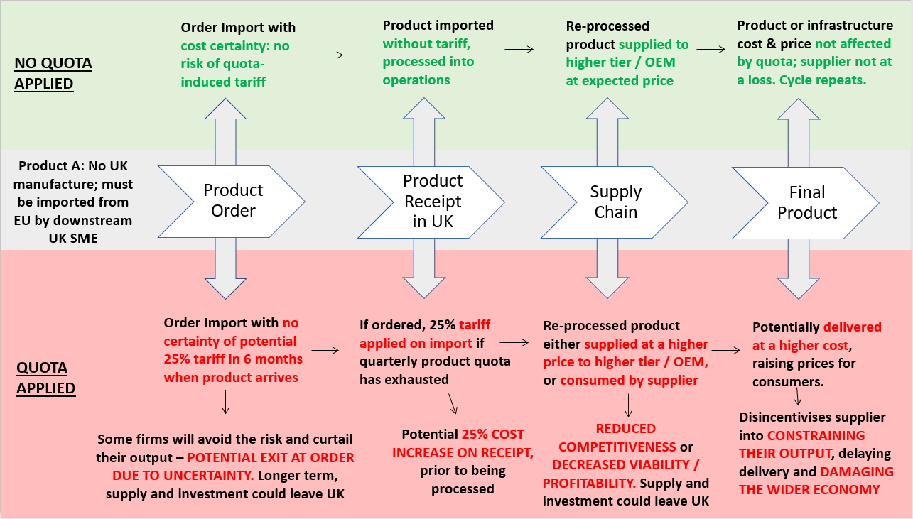**Figure 2: Risks and Costs of Steel Safeguards: A Product Example**

Additionally, characteristics of steel and other metals / materials are extremely conducive to the circular economy and net-zero. Allowing a realistic level of importing would **harness innovation in re-purposing, re-using and recycling of metals in order for the West Midlands and wider UK to become more self-sufficient in future.** In turn this can create jobs, opportunity and lead the green industrial revolution across the whole country.

This reflects a wider need for further public / private collaboration to transition the UK and West Midlands steel industry to technical, financial, and sustainable excellence. The government has **increased its own estimates of the amount of steel it will need for its infrastructure investment plans over the next decade by more than 50%**, with 7.6 million tonnes of steel is needed for public infrastructure plans.[14]

We are keen to understand and **work collaboratively with government on how the UK can meet current and future steel needs of increased public infrastructure spending**, without breaching quotas and incurring tariff costs. This should be in active partnership with, rather than against, UK steel producers and UK Steel – to the benefit of all parties. **We suggest all parties work together to collaborate on a UK steel “supply plan”** that matches the supply and demand for steel in line with the government’s infrastructure, ensuring the UK can be self-sufficient in its delivery of projects – eliciting wider levelling-up and inclusive growth benefits.

1. **System-wide Change to Support Greater Flexibilities, Efficiencies and Management of Safeguarding Measures to the Benefit of All Industry**

**IMPLEMENT CHANGE**

* We suggest the creation of a a more proactive dialogue between government and business on the issue and potential solutions, setting up an immediate, dedicated taskforce that acknowledges the urgency of the situation and develops solutions for industry.
* The development of a more holistic, organised, and long-term approach to steel quotas that is more flexible to the needs of the whole industry and reflects differences across steel categories, eliminating anomalies in the system that disrupt downstream steel users.
* Working collaboratively on a steel supply plan to ensure the UK can meet current and future steel needs of increased public infrastructure spending, without breaching quotas and incurring tariff costs.

**Impact and Conclusion**

The way steel safeguarding measures are currently organised is **damaging to many downstream SMEs who import material** - where they cannot source it from the UK, with consequential impacts on the wider West Midlands and UK economy. Based on historic data, safeguarding measures simply **cannot be accurately tuned to current dynamic market conditions, as evidenced by the live situation of Category 12 and Category 4 grades.** Further cost and risk could not come at a worse time for metals and materials SMEs. The global market is witnessing demand outstrip supply, resulting in **radically extended lead-times, product shortages and extreme cost inflation across all steel grades and raw materials.** More locally, the collapse of Liberty Steel has limited the production of steel in the UK, increasing the demand for imports.

The existence of import safeguards therefore **adds an extra, unnecessary burden onto industry,** particularly damaging supply chain SMEs, at a time when the import of such goods is particularly necessary. This is demonstrated in Figure 3 on the page 12, reflecting that policy decisions in the hand of UK government are exacerbating the impact of market forces, rather than softening them.

The effects are disproportionate to the West Midlands given the significant presence of the metals and materials industry locally: the **industry employs 67,250 people across the three LEP geography, contributing £5.8bn GVA from 4,000 businesses**.[15] It is a unique cluster of strength dominated by SME suppliers.[16] It is clear that quotas are not a small problem, with over **300 companies across the West Midlands importing iron or steel, and 69 importing Category 12 products alone, and 57 importing Cat 4**. These companies **employ 50,000 people across the region**, reflecting the potential scale of the issue.

**Table 3: Number of Importing Businesses & their Total Jobs[17]**

|  |  |  |  |  |  |  |
| --- | --- | --- | --- | --- | --- | --- |
| **Area** | **Importers of Cat 12** | **Jobs** | **Importers of Cat 4** | **Jobs** | **Importers of all Iron and Steel** | **Jobs** |
| Black Country | 25 | 3,000 | 20 | 3,000 | 122 | 29,000 |
| West Midlands Region | 70 | 18,000 | 57 | 46,000 | 321 | 66,000 |
| UK | 390 | 160,000 | 221 | 113,000 | 1,890 | 863,000 |

The difference in safeguard experience and requirement between large steel manufacturers and downstream users must be recognised in order to **build an equitable and well-balanced British steel industry.** While the reasons for introducing and continuing steel safeguarding measures are with the right intentions, the system requires fine-tuning so that the whole industry has a fair, balanced experience and can best represent global Britain.

The West Midlands’ public / industry partnership wants to collaborate with government on fixing specific issues in the system, relieving SMEs of current risks and constraint and unleashing them to take advantage of new domestic and international opportunities. In the short-term this is essential for the efficient delivery of local and national infrastructure plans, driving economic recovery. Longer-term, the wider metals and materials sector will be critical to delivering net-zero and driving a circular economy, leading the way on levelling-up. This is an urgent situation that requires action now

**Figure 3: Safeguards as an Additional Layer of Uncertainty, Cost and Competitiveness for UK Downstream Steel Firms**

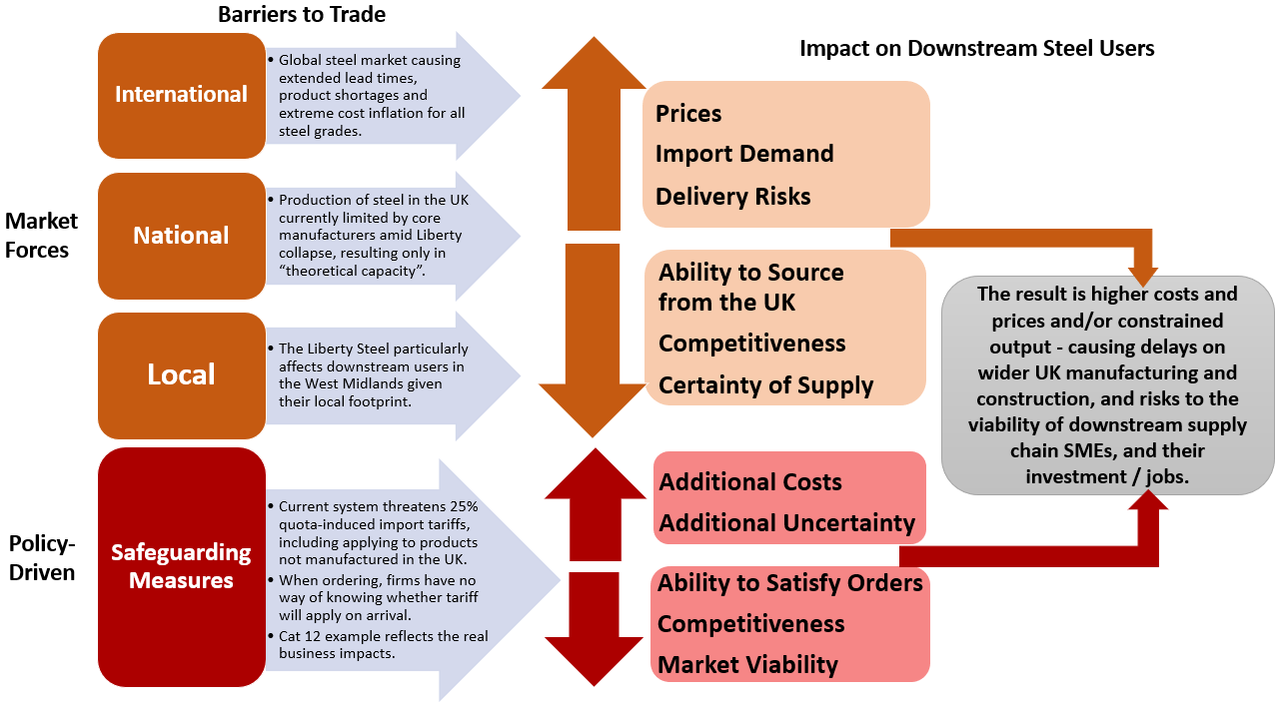

1. <https://www.gov.uk/government/publications/trade-remedies-notice-safeguard-measures-on-certain-steel-products-application-of-tariff-rate-quotas>
2. <https://www.trade-remedies.service.gov.uk/public/case/TF0006/submission/187accc2-e0e6-40b7-8d2f-fdc9b10d536d/>
3. ONS Business Register and Employment Survey (2020) and ONS UK Business Counts (2020); SIC Codes 24 and 25
4. <https://assets.publishing.service.gov.uk/government/uploads/system/uploads/attachment_data/file/1044364/trade-remedies-notice-2021-03-tariff-rate-quota-steel-goods.pdf>
5. <https://www.constructionenquirer.com/2021/05/20/government-needs-an-extra-2-6m-tonnes-of-steel-for-projects/>
6. <https://www.gov.uk/guidance/eu-steel-safeguard-quotas-following-uk-independence-tariff-stop-press-notice-51>
7. <https://researchbriefings.files.parliament.uk/documents/CBP-7317/CBP-7317.pdf>
8. ONS UK Business Counts (2020)
9. ONS Business Register and Employment Survey (2020)
10. Core Steel Sector (Producers) defined by SIC Codes: 24.1, 24.2, 24.3; Downstream Steel Users defined by SIC Codes: 24.52, 25.0 excluding 25.92; Other Metals defined by SIC codes: 24.4, 24.5 excluding 24.52, 25.92.
11. WMCA 3-LEP refers to the three LEP geography related to the West Midlands Combined Authority area: Black Country LEP, Greater Birmingham and Solihull LEP & Coventry & Warwickshire LEP.
12. <https://www.gov.uk/government/news/tra-publishes-final-recommendation-on-steel-safeguard-measures>
13. TRA’s Recommendation to the Secretary of State Transition review TF0006 – Safeguard measure on certain steel products.
14. [Latest figures](https://www.constructionenquirer.com/2021/05/20/government-needs-an-extra-2-6m-tonnes-of-steel-for-projects/) show that over the next decade the government will need an estimated 7.6 million tonnes of steel for public infrastructure plans – up from last year’s estimate of 5 million:
15. Black Country Economic Intelligence Unit Analysis of ONS data
16. The average number of employees is 21 according to UK Metals Council.
17. Figures accessed via DueDil business database. No. of importers relate to record of import from a company from non-EU country, relating to previous years data. It is likely that the numbers of importers is in fact higher due to data gaps.